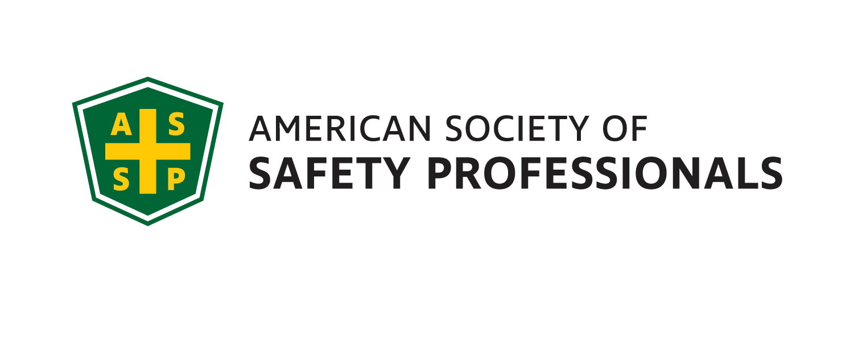
May Meeting / Scholium

Genesee Valley Chapter
Executive Committee
2020-21
JOI
President- Myles Ott, MS
CooperVision, Inc.
president@gvc.assp.org
585-358-1492

President Elect- Mark Flynn
Sales Solutions, Inc.
mark@salessolutionsinc.net

Vice President- Jim Christiano
Dival Safety
jchristiano@divalsafety.com

Membership Chair- Jonathan Aleckna, MS
aleckna.jonathan@gmail.com

Secretary- Alyssa Plow, ASP, EPI
Environmental Resources Mgmt. (ERM)
alyssa.plow@erm.com

Treasurer- Greg Devlin, CSP
U of R – Retired
gregorydevlin@yahoo.com

Student Chapter Advisor –
Joe Rosenbeck, CSP
Rochester Institute of Technology
jmrcem@rit.edu
585-475-6469

Past President - James Locigno, CSP
CooperVision, Inc.
jlocigno@coopervision.com
585-203-7040

Student Chapter Representative
TBD
Rochester Institute of Technology

Openings
Webmaster, Gov. Affairs,
Chapter Delegate, Program Chair

Genesee Valley Chapter (GVC) 2020-21

RIT ESHS Student Presentations

Hosted by: Grant Esler, Professor in the College of Engineering Technology at RIT

This presentation will consist several RIT students presenting on different topics in the field of Environmental, Health and Safety. This is a great opportunity to see the new talent at RIT and to learn about some new or emerging topics in the field of EHS.

Students and their presentation topics are as follows:

Juliana Sanchez – Roofing Falls
Kyla Brown – Mental Health at Work
Sebastian Ospina – Construction Safety Plan
Victoria Cullinan – Home Office Ergonomics
Emma Warnke – Safety and Productivity
Rachel Zachary – Leading and Lagging Indicators

DATE: Tuesday, May 4th, 2021

TIME: 5:00PM
PLACE: Zoom
COST: No charge

Join Zoom Meeting [rit.zoom.us]

Phone one-tap: | US: +16465588656,,93461485969# or +13126266799,,93461485969#
Meeting URL: | https://rit.zoom.us/j/93461485969 [rit.zoom.us]
Meeting ID: | 934 6148 5969

President’s Corner

Greetings colleagues!

A special thanks to Nick Donofrio, Compliance Assistance Specialist - New York Regional Office US Dept of Labor / OSHA for his March presentation on the OSHA National Emphasis Program on eliminating amputation injuries. During March’s presentation Nick also discussed the upcoming Region 2 Amputation Safety Stand Down. As a reminder there will be an OSHA region 2 National Safety Stand-down to Prevent Falls in Construction kicking off on Monday May 3rd.

I am excited to announce that the GVC ASSP chapter will be holding its annual RIT Environmental Sustainability, Health and Safety Student Presentations. This event is scheduled for May 4th at 5pm. For those who have not had the opportunity to attend this meeting, the presentations are given by students at RIT in the ESHS program. The presentation normally consists of emerging topics in the EHS field or a deep dive into a topic of the student’s interest. I would encourage you to block off time on your calendar to help support the next generation of safety professionals. I look forward to virtually seeing you all there!

If you have any questions please feel free to email me at: president@gvc.assp.org
Myles Ott
President – Genesee Valley Chapter, ASSP

