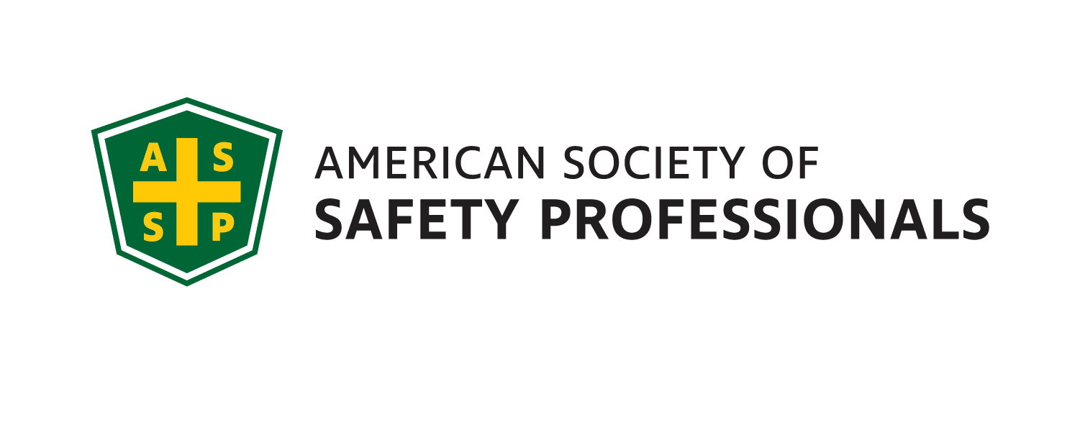
September 2021 Meeting / Scholium

Genesee Valley Chapter
Executive Committee
2021-22
JOI
President - Mark Flynn
585-455-1742
Sales Solutions, Inc.
mark@salessolutionsinc.net

Vice President- Jim Christiano
Dival Safety
jchristiano@divalsafety.com

Membership Chair- Jonathan Aleckna, MS
aleckna.jonathan@gmail.com

Secretary- Alyssa St. Pierre, ASP, EPI
Environmental Resources Mgmt. (ERM)
alstpierre@ecoopervision.com

Treasurer- Greg Devlin, CSP
U of R – Retired
gregorydevlin@yahoo.com

Student Chapter Advisor –
Joe Rosenbeck, CSP
Rochester Institute of Technology
jmrcem@rit.edu
585-475-6469

Student Chapter Representative
Jordynn Huckabone
Rochester Institute of Technology
jxh1821@rit.edu

Openings:
Webmaster, Gov. Affairs,
Chapter Delegate, Program Chair

Genesee Valley Chapter (GVC) 2021-22

Networking Social

This meeting will include a talk from Greg Devlin, member of the Amp Stand Down Education Committee, about the OSHA Region 2 Amputation Safety Stand Down and a Network social.

DATE: Tuesday, September 15th, 2021

TIME: 5:00PM – 6:30PM

PLACE: Lovin’ Cup (outside under their tent)
300 Park Point Drive, Suite 101
Rochester, NY 14623

COST: No Cost – Hors D’oeuvres will be served, Cash Bar

RESERVATIONS: Please RSVP by
Monday, Sept. 13 on our website at:
https://gvc.assp.org/events/genesee-valley-assp-networking-social/

Local Job Openings:
The Gleason Works
Environmental Health & Safety Manager
The Safety Manager is responsible for developing, coordinating and promoting all environmental, health and safety programs for The Gleason Works (GWR). This position will develop the EH&S culture along with the GWR Leadership team to ensure legal compliance with all environmental, health, safety and OSHA laws and regulations.
To learn more: https://us60.dayforcehcm.com/CandidatePortal/en-US/Gleason/Posting/View/548
HP Hood
Batavia, NY 14020
EHS Specialist
https://recruiting.ultipro.com/HPH1000/JobBoard/b4489760-cbeb-e7d1-67b6-4c4d81bfa181/Opportunity/OpportunityDetail?opportunityId=5f85d238-b14f-4df8-9854-27cc2522bdf0

President’s Corner

Greetings colleagues!
The Genesee Valley ASSP Executive Committee is looking forward to kicking off the 2021 - 2022 Chapter year with our annual Network Social at Lovin’ Cup. One of our goals this year will be to return to in-person meetings as much as possible, providing it is safe to do so. Therefor this event will be held outside, in a covered area under their tent. Other goals will be to grow our local Chapter’s membership, increase the attendance at our monthly meetings and continue to support the local RIT Student ASSP Chapter.

I would like to thank our past President, Myles Ott, along with the other committee members and all of the presenters from this past year that helped our Chapter achieve Silver-level recognition for the second consecutive year.

Here is our schedule for the remainder of this year:
- 10/13/21: RIT Student Chapter
- 11/10/21: Annual OSHA Update by Nick Donofrio, Compliance Assistance Specialist, NY Regional Office US Department of Labor / OSHA – 11:30am – 1:30pm (location TBD)
- 12/1/21: Genesee Valley & Finger Lakes EH&S Professional Development Conference (location – Holiday Inn Downtown Rochester)
  - 12/1/21 – Holiday Social immediately following the PDC

We look forward to seeing you on September 15th .

Thank you and be safe!

Mark Flynn
President – Genesee Valley Chapter, ASSP

