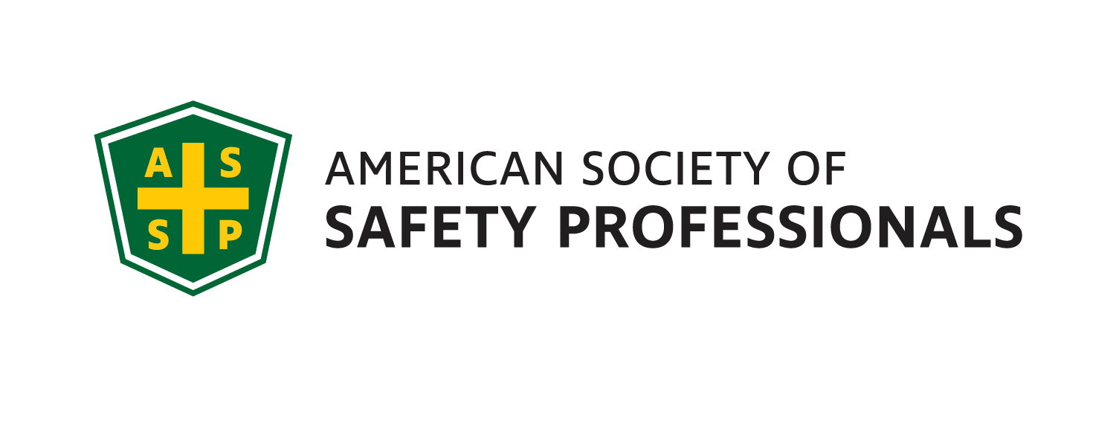
October 2021 Meeting / Scholium

Genesee Valley Chapter
Executive Committee
2021-22
JOI
President - Mark Flynn
585-455-1742
Sales Solutions, Inc.
mark@salessolutionsinc.net

Vice President- Jim Christiano
Dival Safety
jchristiano@divalsafety.com

Membership Chair- Jonathan Aleckna, MS
aleckna.jonathan@gmail.com

Secretary- Alyssa St. Pierre, ASP, EPI
Environmental Resources Mgmt. (ERM)
alstpierre@ecoopervision.com

Treasurer- Greg Devlin, CSP
U of R – Retired
gregorydevlin@yahoo.com

Student Chapter Advisor –
Joe Rosenbeck, CSP
Rochester Institute of Technology
jmrcem@rit.edu
585-475-6469

Student Chapter Representative
Jordynn Huckabone
Rochester Institute of Technology
jxh1821@rit.edu

Openings:
Webmaster, Gov. Affairs,
Chapter Delegate, Program Chair

Genesee Valley Chapter (GVC) 2021-22

Panel discussion on Covid-19

The ASSP GVC Board is proud to present a panel discussion about the current state of the COVID-19 pandemic. We look forward to having local safety professionals share their best practices in dealing with COVID-19 in their workplace. This will be an interactive forum, including time to ask questions.

Safety Panelists include:
- James Locigno, Cooper Vision
- Dick Flint, Lonza
- Loic Williamson, Canandaigua Wine
- Taylor Potter, Akoustis
- Ryan Farrell, Arkema

DATE: Wednesday, October 13th, 2021

TIME: 11:30AM – 1:00PM

PLACE: Virtual - Microsoft Teams Link to meeting; https://teams.microsoft.com/l/meetup-join/19%3ameeting_ZTBjNjRhZTUtNzRjZi00Mjg1LWIyZmYtZTZkMmEwYmFiOWJm%40thread.v2/0?context=%7b%22Tid%22%3a%22c89328d9-1dc7-42e6-8802-f7fd08c69691%22%2c%22Oid%22%3a%2203ab8e7a-0ec3-4906-a68e-063381e6e2af%22%7d

Local Job Openings:

Li-Cycle
Health and Safety Specialst
Li-Cycle is continuing to recruit for a Health and Safety Specialist role supporting our current Rochester, NY operations with
the potential for expansion into regional responsibilities as we continue to grow.
To learn more:
https://licycle.bamboohr.com/jobs/view.php?id=168

The Gleason Works
Environmental Health & Safety Manager
The Safety Manager is responsible for developing, coordinating and promoting all environmental, health and safety programs for The Gleason Works (GWR). This position will develop the EH&S culture along with the GWR Leadership team to ensure legal compliance with all environmental, health, safety and OSHA laws and regulations.
To learn more: https://us60.dayforcehcm.com/CandidatePortal/en-US/Gleason/Posting/View/548
HP Hood
Batavia, NY 14020
EHS Specialist
https://recruiting.ultipro.com/HPH1000/JobBoard/b4489760-cbeb-e7d1-67b6-4c4d81bfa181/Opportunity/OpportunityDetail?opportunityId=5f85d238-b14f-4df8-9854-27cc2522bdf0

President’s Corner

Greetings colleagues!
The Genesee Valley ASSP Chapter kicked off the year with a great turnout at our Network Social at Lovin’ Cup last month! Thanks to all who participated, including those from the local Student Chapter at RIT.

I would like to thank our Vice President, Jim Christiano, for working diligently to put this panel together as well as the panelists who volunteered to participate.

Here is our schedule for the remainder of this year:
- 11/10/21: Annual OSHA Update by Nick Donofrio, Compliance Assistance Specialist, NY Regional Office US Department of Labor / OSHA – 11:30am – 1:30pm (location TBD)
- 12/1/21: Genesee Valley & Finger Lakes EH&S Professional Development Conference (location – Holiday Inn Downtown Rochester)
  - 12/1/21 – Holiday Social immediately following the PDC

We look forward to seeing you on our October 13th Virtual Meeting.

Thank you and be safe!

Mark Flynn
President – Genesee Valley Chapter, ASSP

