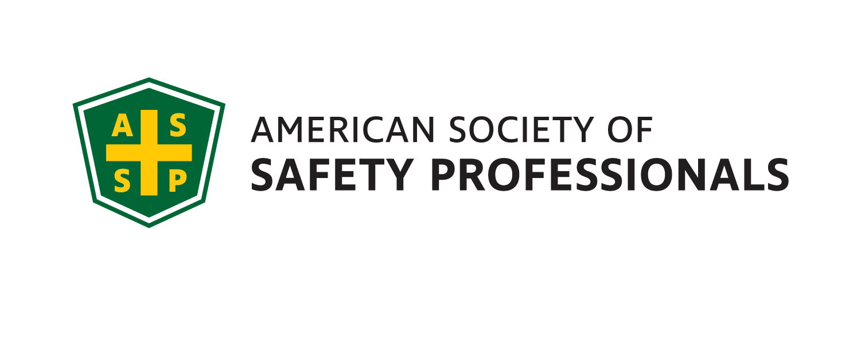
November 2021
Meeting/Scholium

Genesee Valley Chapter
Executive Committee
2021-22
JOI
President - Mark Flynn
585-455-1742
Sales Solutions, Inc.
mark@salessolutionsinc.net

Vice President- Jim Christiano
Dival Safety
jchristiano@divalsafety.com

Membership Chair- Jonathan Aleckna, MS
aleckna.jonathan@gmail.com

Secretary- Alyssa St. Pierre, ASP, EPI
Environmental Resources Mgmt. (ERM)
alstpierre@ecoopervision.com

Treasurer- Greg Devlin, CSP
U of R – Retired
gregorydevlin@yahoo.com

Student Chapter Advisor –
Joe Rosenbeck, CSP
Rochester Institute of Technology
jmrcem@rit.edu
585-475-6469

Student Chapter Representative
Jordynn Huckabone
Rochester Institute of Technology
jxh1821@rit.edu

Genesee Valley Chapter

(GVC) 2021-22

Annual OSHA Update
Meeting

The ASSP GVC Board is proud to present our Annual OSHA Update meeting presented by Nick Donofrio, Compliance Assistance Specialist – NY Regional Office of the US Department of Labor / OSHA. Nick will present on a range of topics including the recent FY Top 10 OSHA Citations, Update on the COVID-19 Vaccine ETS, OSHA Heat Illness initiative, etc.

DATE: Friday, November 12th, 2021

TIME: 11:30AM – 1:00PM

PLACE: Virtual - Microsoft Teams Link;

Click here to join the meeting

Local Job Openings:

Chubb
Property & Casualty Risk Engineer:
The Property & Casualty Risk Engineer (PCRE)
professional operates within the Risk Engineering Services
Department and is considered an integral component of
the valued added services that we provide for our
commercial insurance policy holders.
The position will report to the New Haven Risk Engineering
Branch Manager and directly support our Northeast
Region (Buffalo, Rochester, Syracuse, Ithaca, Utica and
other upstate NY areas).

https://careers.chubb.com/global/en/job/341621/Sr-Property-Casualty-Risk-Engineer

Li-Cycle
Health and Safety Specialist
Li-Cycle is continuing to recruit for a Health and Safety Specialist role supporting our current Rochester, NY operations with
the potential for expansion into regional responsibilities as we continue to grow.
To learn more:
https://licycle.bamboohr.com/jobs/view.php?id=168

The Gleason Works
Environmental Health & Safety Manager
The Safety Manager is responsible for developing, coordinating and promoting all environmental, health and safety programs for The Gleason Works (GWR). This

position will develop the EH&S culture along with the GWR Leadership team to ensure legal compliance with all environmental, health, safety and OSHA laws and regulations.
To learn more: https://us60.dayforcehcm.com/CandidatePortal/en-US/Gleason/Posting/View/548
HP Hood
Batavia, NY 14020
EHS Specialist
https://recruiting.ultipro.com/HPH1000/JobBoard/b4489760-cbeb-e7d1-67b6-4c4d81bfa181/Opportunity/OpportunityDetail?opportunityId=5f85d238-b14f-4df8-9854-27cc2522bdf0

President’s Corner

Greetings colleagues!

The Genesee Valley ASSP Chapter would like to thank the following EH&S Professionals that volunteered to be panelists on our COVID-19 meeting earlier this month:
- Danielle Grabowski from FIFCO / Genesee Brewing Company
- Loic Williamson from Canandaigua Wine
- James Locigno from CooperVision Inc.

Here is our schedule for the remainder of this year:
- 12/1/21: Genesee Valley & Finger Lakes EH&S Professional Development Conference (location – Holiday Inn Downtown Rochester)
  - 12/1/21 – Holiday Social immediately following the PDC

We look forward to seeing you on our November 12th Virtual Meeting.

Thank you and be safe!

Mark Flynn
President – Genesee Valley Chapter, ASSP

