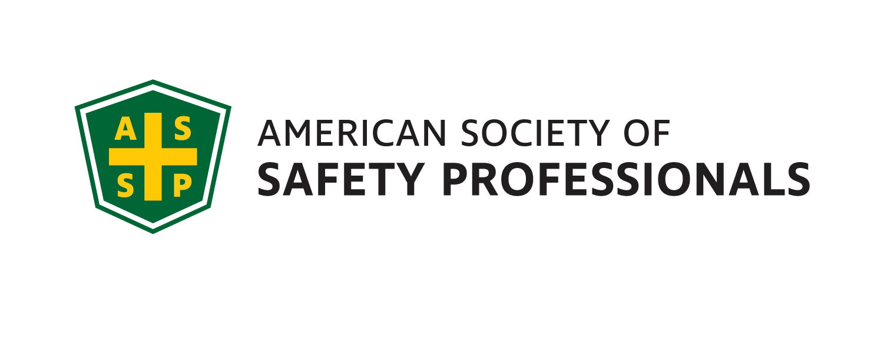
January 2022
Meeting/Scholium

Genesee Valley Chapter
Executive Committee
2021-22
JOI
President - Mark Flynn
585-455-1742
Sales Solutions, Inc.
mark@salessolutionsinc.net

Vice President- Jim Christiano
Dival Safety
jchristiano@divalsafety.com

Membership Chair- Jonathan Aleckna, MS
aleckna.jonathan@gmail.com

Secretary- Alyssa St. Pierre, ASP, EPI
EHS Specialist, CooperVision
alstpierre@ecoopervision.com

Treasurer- Jennifer Years, CSP
EHS Manager, Hammer Packaging
jyears@hammerpackaging.com

Student Chapter Advisor –
Joe Rosenbeck, CSP
Rochester Institute of Technology
jmrcem@rit.edu
585-475-6469

Student Chapter Representative
Jordynn Huckabone
Rochester Institute of Technology
jxh1821@rit.edu

Genesee Valley Chapter

(GVC) 2021-22

January Meeting

The ASSP GVC Board is excited to have Bruce Bolger present “Critical Strategies Necessary to Engage Your Leadership Team and Workforce in Your Journey of Safety Culture Excellence.”

Bruce Bolger is a Certified Safety Professional (CSP) and Certified Hazardous Materials Manager (CHMM) focusing on Safety, Human Performance and Transformational Leadership. Bruce has over 40 years of experience with high performance work teams, and we look forward to his presentation.

DATE: Tuesday, January 18th

TIME: 7:30AM – 9:00AM

PLACE: Virtual - Microsoft Teams Link;

Click here to join the meeting

Local Job Openings:
Carestream EHS has a great opportunity and career opening for an EHS Operations Manager at its 1049 Ridge Road Rochester, NY manufacturing facility. If you have at least 10 years of EHS experience and a history of strong leadership, this position may be for you.

Here is a link to this job posting;

Environment, Health and Safety Manager | Carestream | LinkedIn
President’s Corner

Greetings colleagues!

The Genesee Valley ASSP Chapter would like to congratulate Greg Devlin, who was recently elected as the new ASSP Empire State Area Director, overseeing the Genesee, Niagara, Central NY and Capital Region chapters. We thank Greg for his many years of service as the Genesee Valley Chapter Treasurer and look forward to his leadership in this new position.

Jennifer Years, CSP has stepped forward to take the Chapter’s Treasurer position. Jennifer is an EHS Manager for Hammer Packaging, a Fort Dearborn/MCC Label Company, and a Certified Trainer for the American Red Cross. With over 27 years of experience in EHS, Jennifer has worked in the following industries; food and beverage manufacturing, personal care product manufacturing, public/municipality safety, construction, and amusement parks safety. Jennifer started as an EMT for volunteer fire but decided it was much better to prevent injuries than respond to them. Please join us in welcoming Jennifer to the Genesee Valley Chapter’s board.

Here is our schedule for the remainder of this year:
- February – Tentative – “Lone Worker” Safety
- March – Tentative - ASSP/AIHA Joint Meeting
- April – RIT Student Chapter Presentations

We look forward to seeing you on our January 18th Virtual Meeting.

Thank you and Happy New Year!

Mark Flynn
President – Genesee Valley Chapter, ASSP

